Name: Svitlana Azarenko

Course: Data Analytics

Assignment: Snowflake Data Analytics Practice (Snowpark + Python)

Task 1 — Daily Revenue Aggregation (Snowpark SQL)

Source: V_SALES_ENRICHED (DEMO_DW.SALES)
Goal: Calculate total revenue per FULL_DATE using Snowpark aggregation.
Tool: Snowpark
code
# The Snowpark package is required for Python Worksheets.
# You can add more packages by selecting them using the Packages control and then importing them.

import snowflake.snowpark as snowpark
from snowflake.snowpark.functions import col

def main(session: snowpark.Session):
# Your code goes here, inside the "main" handler.
tableName = 'information_schema.packages'
dataframe = session.table(tableName).filter(col("language") == 'python')

# Print a sample of the dataframe to standard output.
dataframe.show()

# Return value will appear in the Results tab.
return dataframe

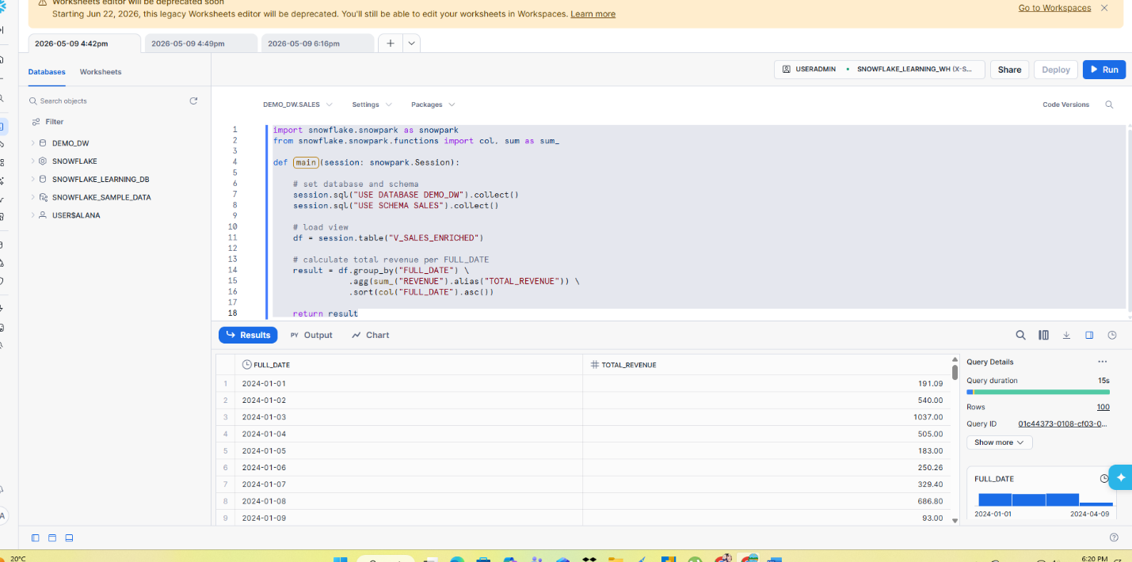

Task 2 — Top 10 Highest-Grossing Products (Snowpark)

Source: FACT_SALES (DEMO_DW.SALES)
Goal: Top 10 products by revenue
Tool: Snowpark

code
import snowflake.snowpark as snowpark
from snowflake.snowpark.functions import col, sum as sum_

def main(session: snowpark.Session):

# load FACT_SALES table
df = session.table("DEMO_DW.SALES.FACT_SALES")

# create REVENUE column
df = df.with_column("REVENUE", col("UNIT_PRICE") * col("QTY"))

# aggregate total revenue per PRODUCT_KEY
result = df.group_by("PRODUCT_KEY") \
.agg(sum_("REVENUE").alias("TOTAL_REVENUE")) \
.sort(col("TOTAL_REVENUE").desc()) \
.limit(10)

return result

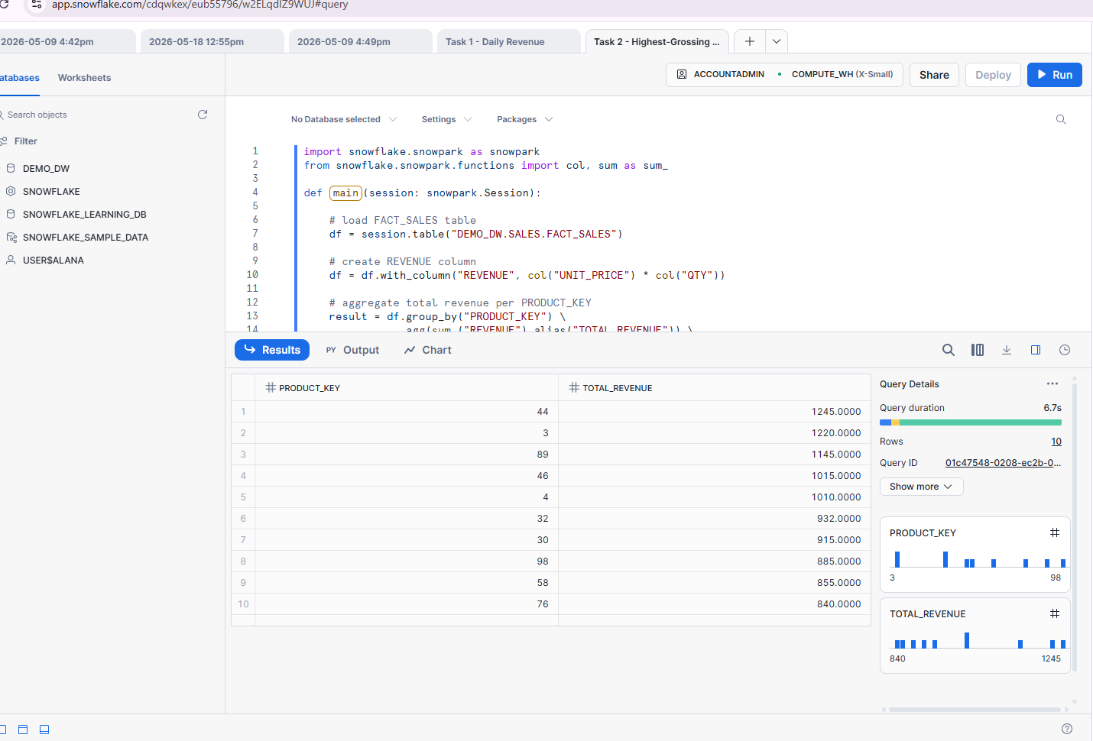

Task 3 — Revenue Statistics Analysis (NumPy)
Source: V_SALES_ENRICHED
Goal: Revenue statistics (mean, std, min, max)
Tool: Snowpark + NumPy

code
import snowflake.snowpark as snowpark
import numpy as np

def main(session: snowpark.Session):

# load view
df = session.table("DEMO_DW.SALES.V_SALES_ENRICHED")

# select REVENUE column
df_revenue = df.select("REVENUE")

# convert to pandas
pdf = df_revenue.to_pandas()

# convert to NumPy array
revenue_array = pdf["REVENUE"].to_numpy()

# calculate statistics
avg_revenue = np.mean(revenue_array)
std_revenue = np.std(revenue_array)
min_revenue = np.min(revenue_array)
max_revenue = np.max(revenue_array)

# print results
print("Average Revenue:", avg_revenue)
print("Standard Deviation:", std_revenue)
print("Minimum Revenue:", min_revenue)
print("Maximum Revenue:", max_revenue)

return df_revenue
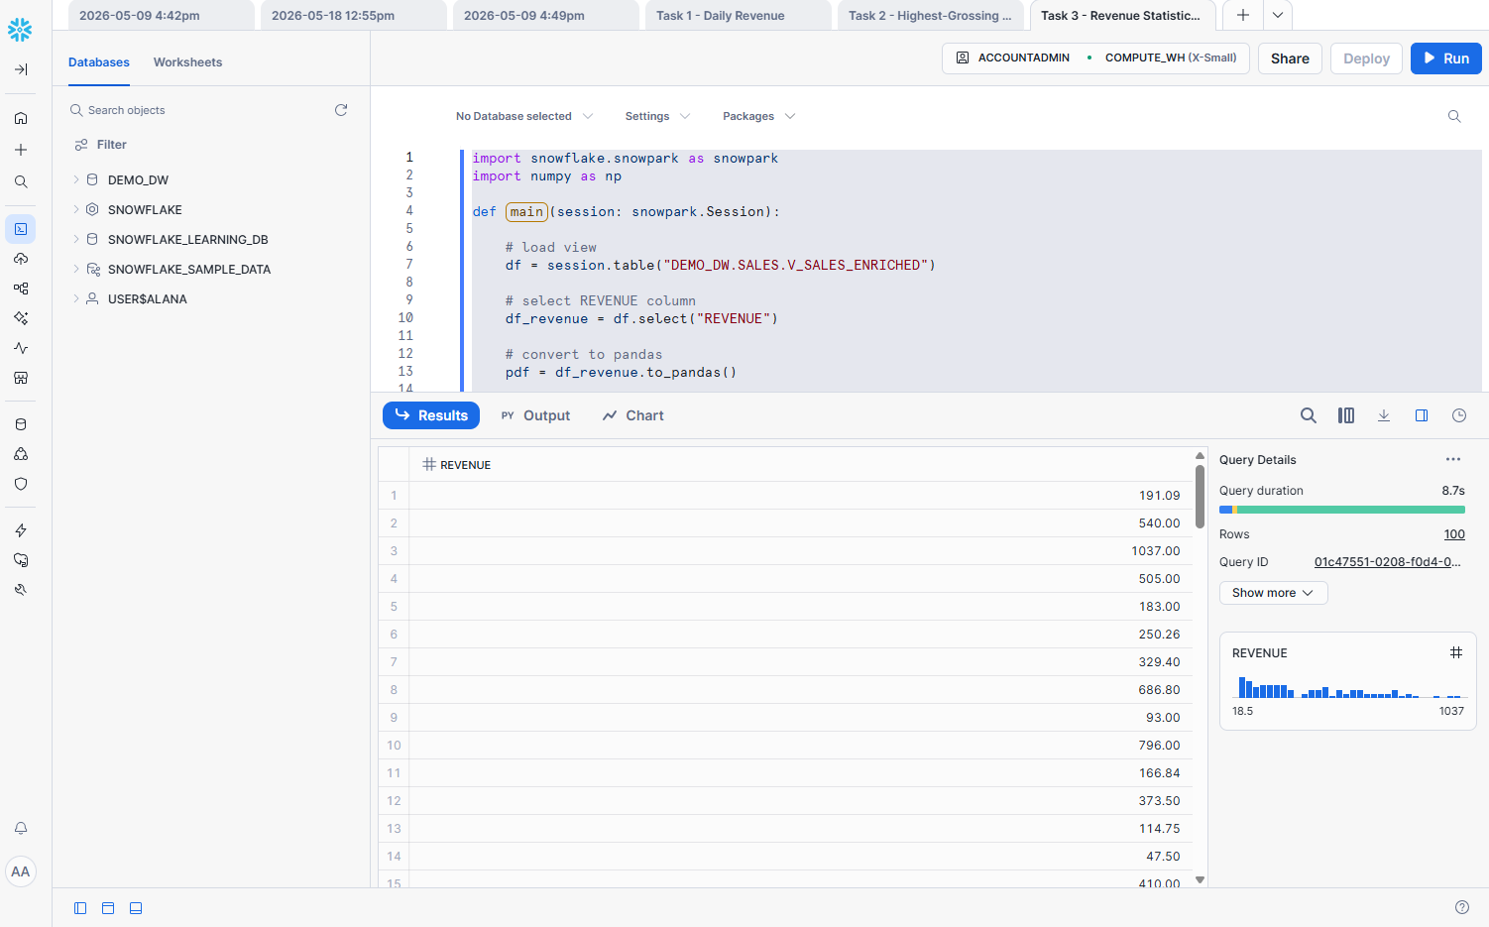

Task 4 — Synthetic Sales Data Simulation (NumPy)
Source: Synthetic data (generated)
Goal: Simulate sales data (QTY, PRICE, REVENUE)
Tool: NumPy

code
import snowflake.snowpark as snowpark
import numpy as np

def main(session: snowpark.Session):

# create random arrays
qty = np.random.randint(1, 13, 20)
price = np.random.randint(10, 251, 20)
revenue = qty * price

# print arrays
print("QTY:", qty)
print("UNIT_PRICE:", price)
print("REVENUE:", revenue)

# convert to Snowpark DataFrame (FIX)
data = [(int(q), int(p), int(r)) for q, p, r in zip(qty, price, revenue)]

df = session.create_dataframe(data, schema=["QTY", "UNIT_PRICE", "REVENUE"])

return df

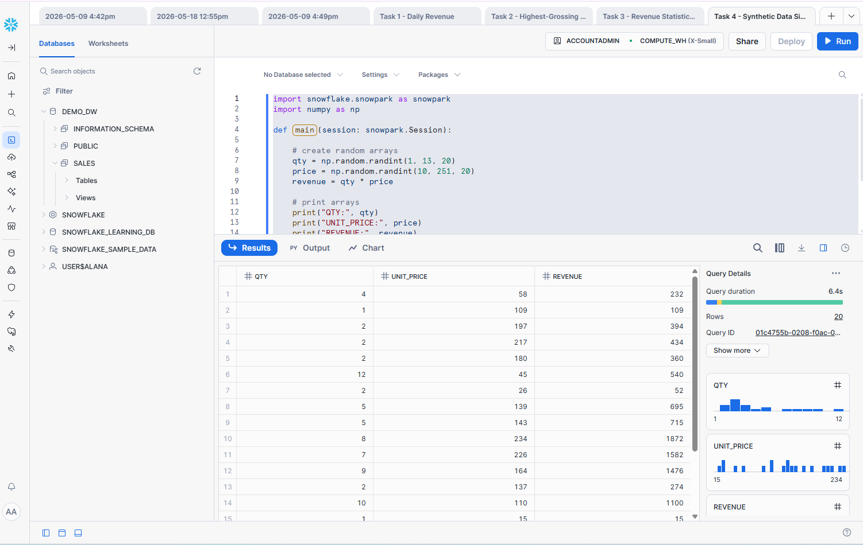

Task 5 — Category Revenue Summary (Pandas)
Source: V_SALES_ENRICHED
Goal: Top 3 categories by revenue
Tool: Pandas

code
import snowflake.snowpark as snowpark
import pandas as pd

def main(session: snowpark.Session):

# FIX: set context
session.sql("USE DATABASE DEMO_DW").collect()
session.sql("USE SCHEMA SALES").collect()

# load view
df = session.table("V_SALES_ENRICHED")

# convert to pandas
pdf = df.to_pandas()

# group by CATEGORY
result = pdf.groupby("CATEGORY")["REVENUE"].sum().reset_index()

# sort
result = result.sort_values(by="REVENUE", ascending=False)

# top 3
top3 = result.head(3)

print(top3)

# return Snowpark DataFrame
return session.create_dataframe(top3)

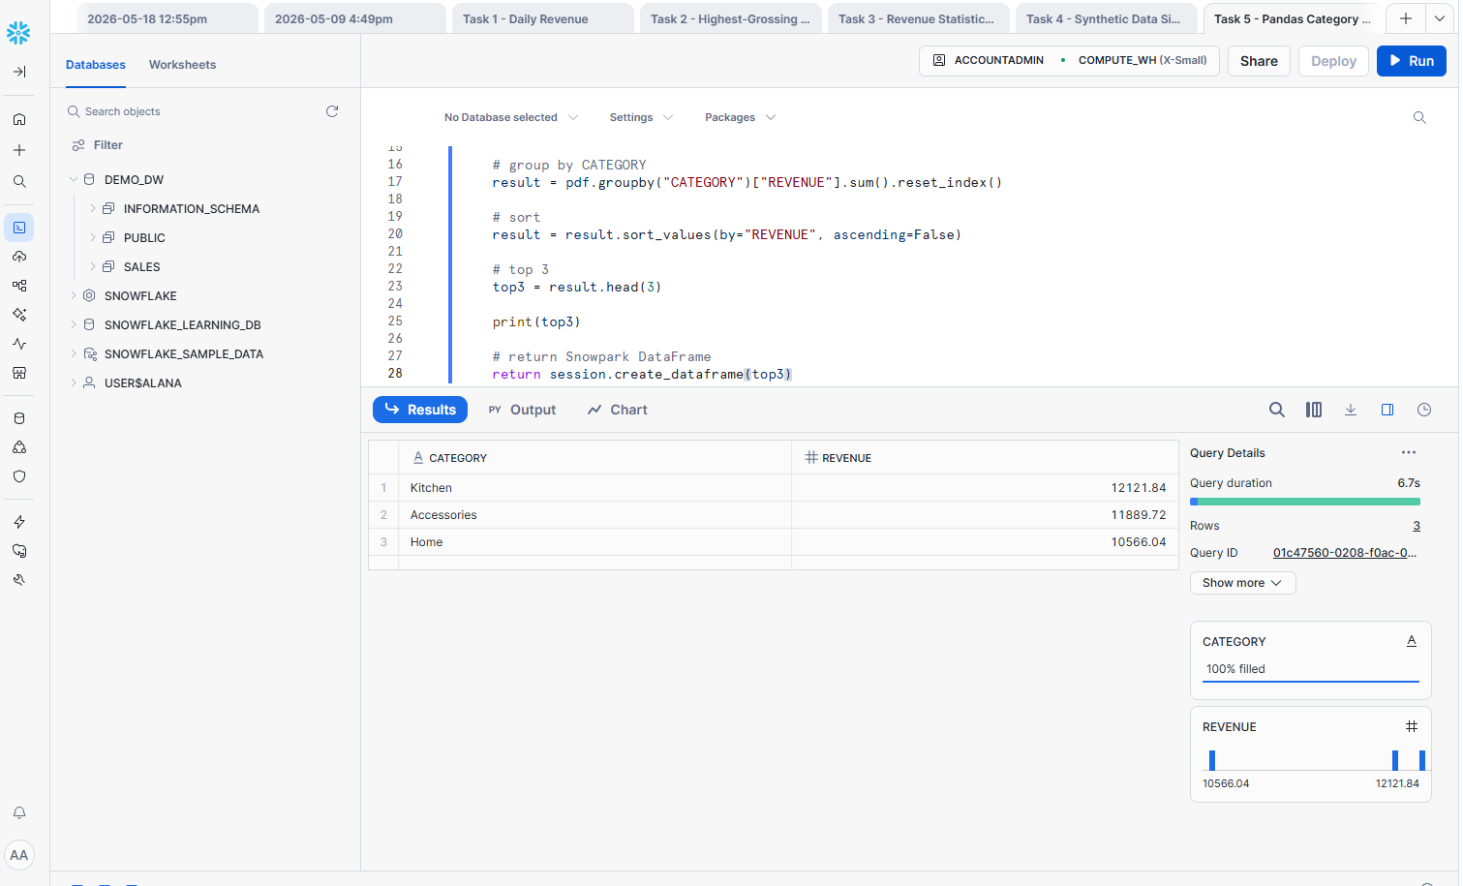

Task 6 — Store Traffic Conversion Analysis

Source: V_TRAFFIC_ENRICHED
Goal: Store conversion (sessions → orders rate)
Tool: Pandas

code
import snowflake.snowpark as snowpark
import pandas as pd

def main(session: snowpark.Session):

# FIX: set context (important for your error)
session.sql("USE DATABASE DEMO_DW").collect()
session.sql("USE SCHEMA SALES").collect()

# load view
df = session.table("V_TRAFFIC_ENRICHED")

# convert to pandas
pdf = df.to_pandas()

# aggregate per store
grouped = pdf.groupby("STORE_NAME").agg(
TOTAL_SESSIONS=("SESSIONS", "sum"),
TOTAL_ORDERS=("ORDERS", "sum")
).reset_index()

# create conversion metric
grouped["ORDERS_PER_SESSION"] = grouped["TOTAL_ORDERS"] / grouped["TOTAL_SESSIONS"]

print(grouped)

# return Snowpark DataFrame
return session.create_dataframe(grouped)

